**Name:** Swagat Panda

**ID:** 2017B5A30983P

**Lab VI**

**Study and design of active filters using LM741**

Objectives

To study the following active filters using op-amp LM741

* Low Pass Filter
* High Pass Filter
* Band Pass Filter and find out

and

* Plot of voltage gain vs frequency (Bode Plot) for all three different filters
* Calculate 3dB frequency and compare it with simulation in a tabular format
* Also draw the schematic for each filter

Sallen-Key Active Filters

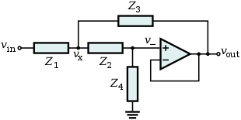

The Sallen-Key Topology

1. Low Pass Filter

Schematic and Frequency Response Plot

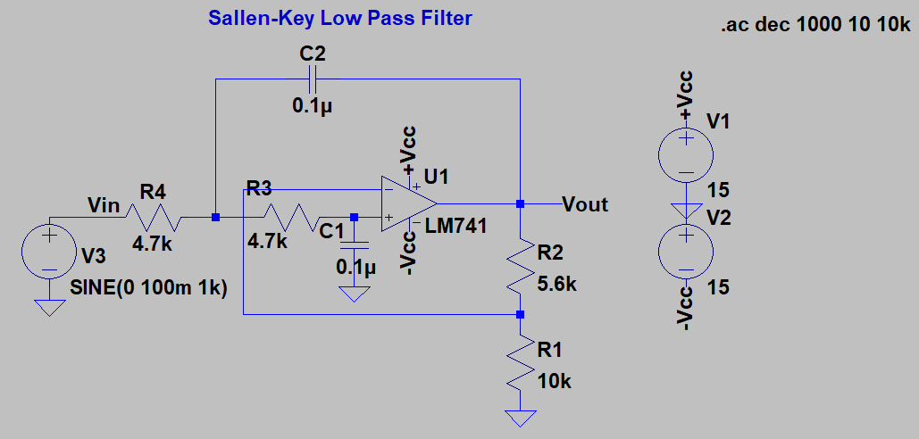

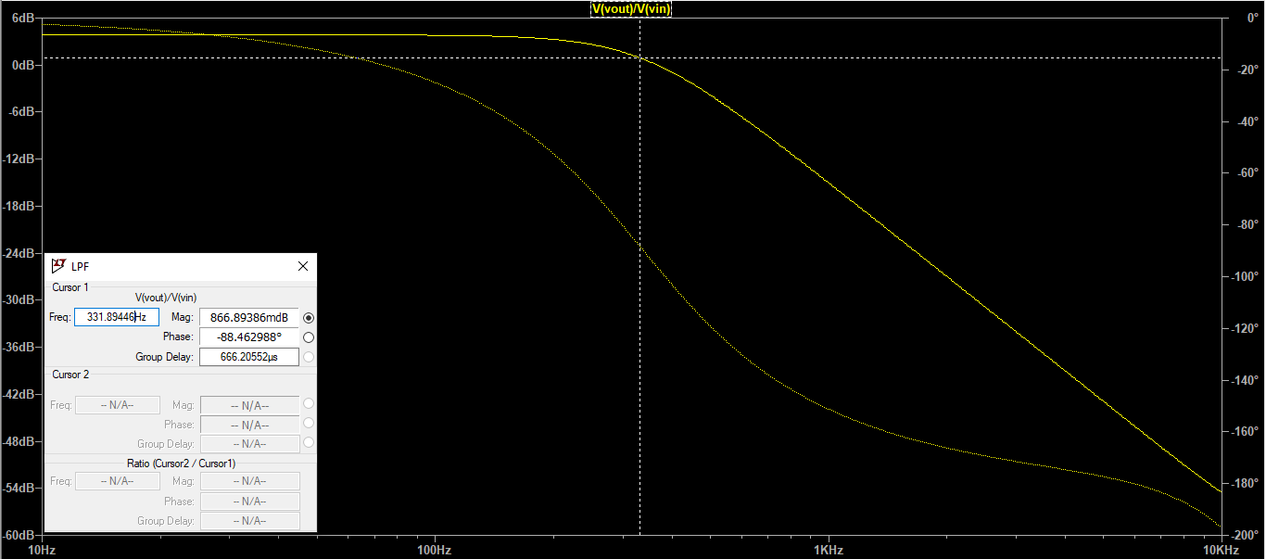

1. High Pass Filter

Schematic and Frequency Response Plot

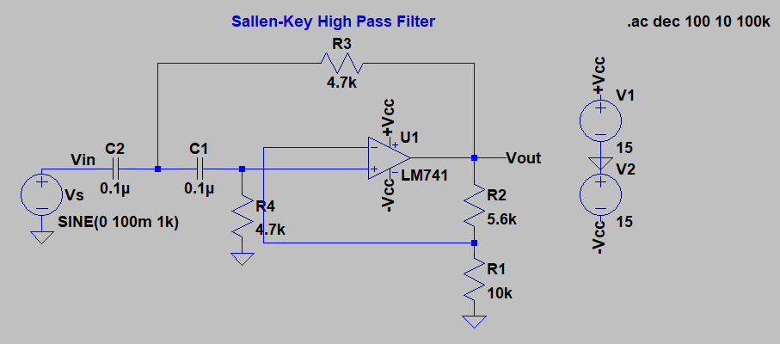

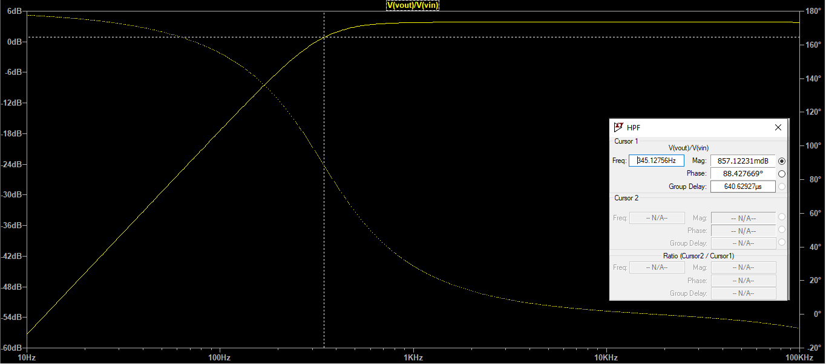

1. Band Pass Filter

Schematic and Frequency Response Plot

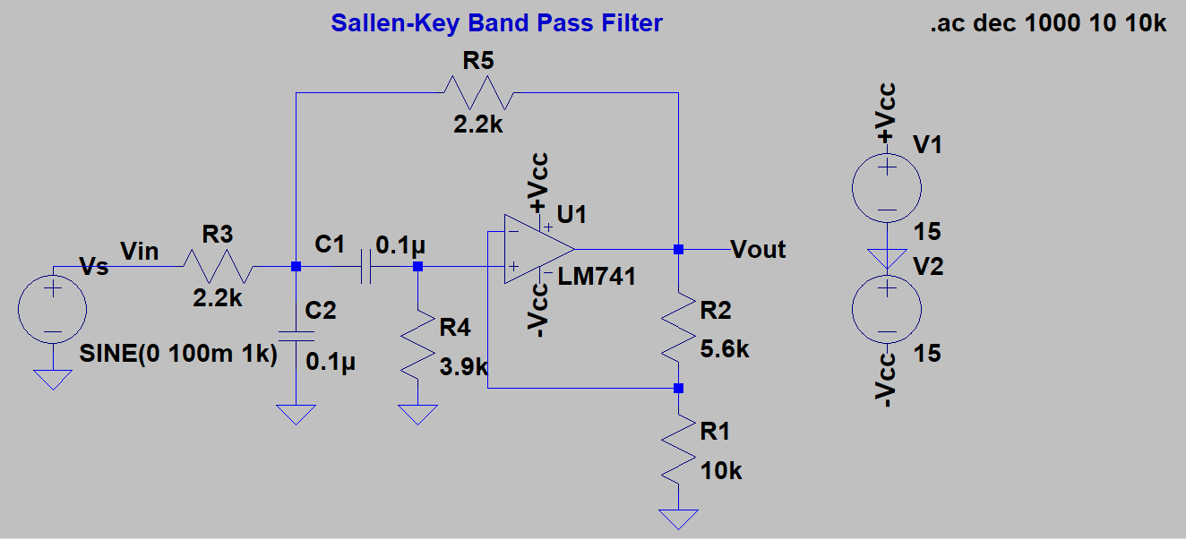

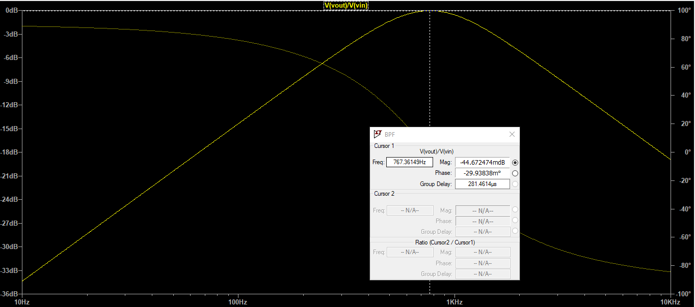

Results

|  |  |  |
| --- | --- | --- |
| **Type of filter** | **Theoretical value of 3dB/cutoff frequency** | **Simulated value of 3dB/corner frequency** |
| Low pass filter | $$\frac{1}{2πRC}=\frac{1}{2π×4.7k×0.1μ}=338.627 Hz$$ | 331.894 Hz |
| High pass filter | $$\frac{1}{2πRC}=\frac{1}{2π×4.7k×0.1μ}=338.627 Hz$$ | 345.127 Hz |
| Band-pass filter | $$\frac{1}{2π\sqrt{\frac{R_{3}R_{4}{R_{5}C}_{1}C_{2}}{R_{3}+R_{5}}}}=\frac{1}{2π×2071.23×0.1μ}=768.407 Hz$$ | 767.361 Hz |